# **TDOC-009 Date:10/09/2019**

## camera motion detection/face tracking with tg-18

### project description

This project deals with the camera face tracking by using the Viola-Jones for face detection and Camshift as the object tracker.

The Accord firmware is used for the tracking scripts.

The processing 3.5 Java is used for the secondary calibration application.

Flow chart of the programs :

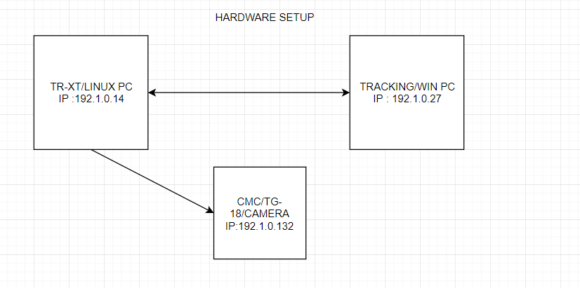

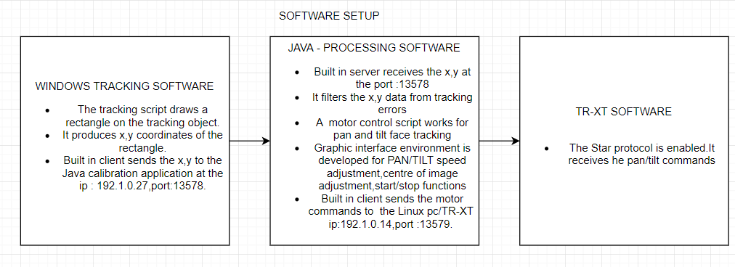

### windows tracking application

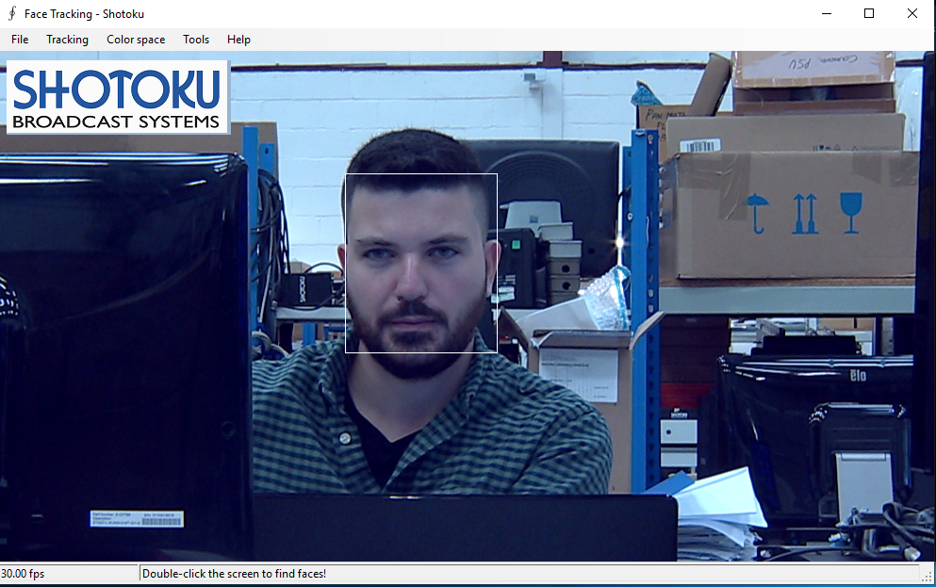

Face (or object) tracking using Viola-Jones for face detection and Camshift as the object tracker. Can be used in RGB and HSL color spaces (may require some tuning for HSL)

### processing java calibration appplication

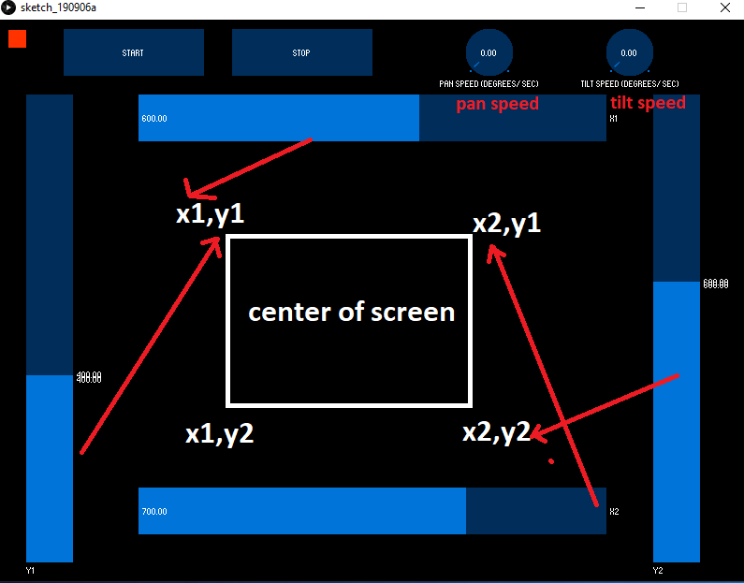

This application is designed for the adjustment of the reference center point of the tracking. The user uses the x1,x2,y1,y2 sliders. Each slider is a variable. The 4 sliders create 4 points and a rectangle (Green rectangle on the following pictures). So the head always tries to keep the face tracking rectangle inside the designed from the sliders rectangle.

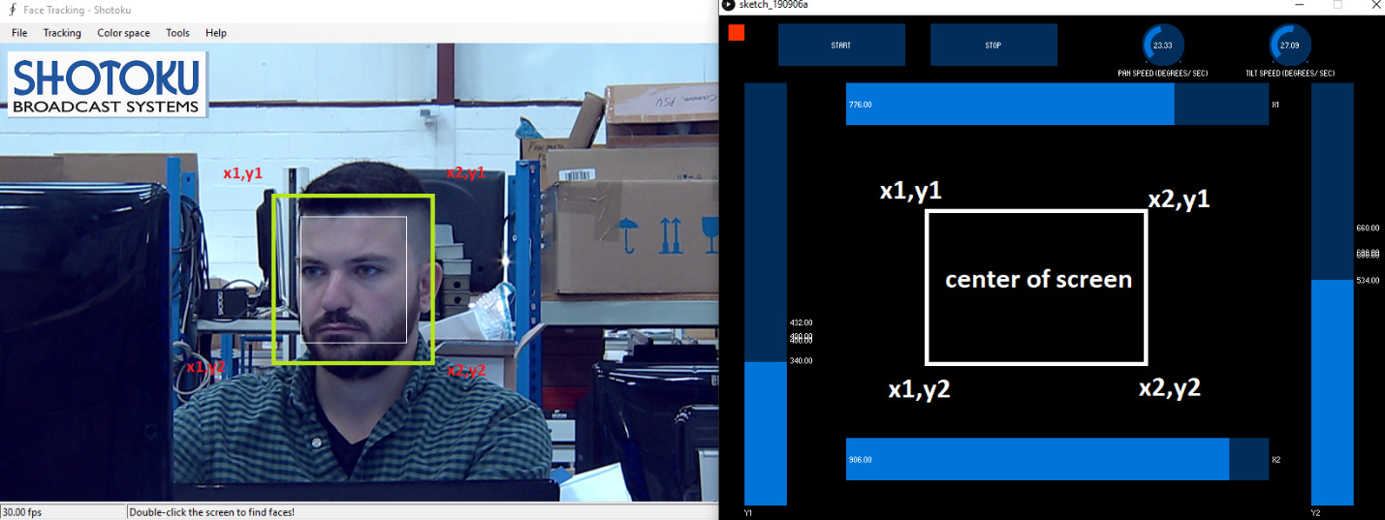

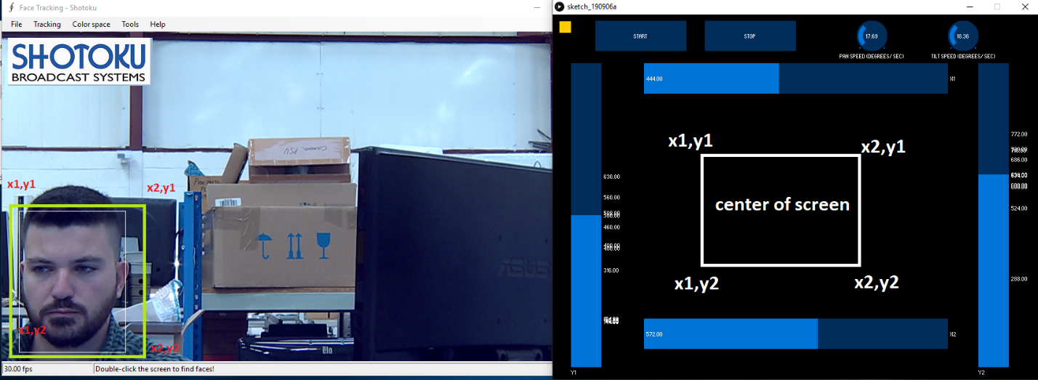

Also the 2 round shape sliders adjust the pan and tilt speeds. This tool is useful when we zoom in to an object/face.

### software setup – instructions - demo

**Step 1:** Processing accord 6/sketch/application.windows64/sketch_190906a.exe

Run the .exe



**Step 2:** 10/Face tracking.exe

Run the .exe. An installation will automatically start. After the installation the program will start automatically.

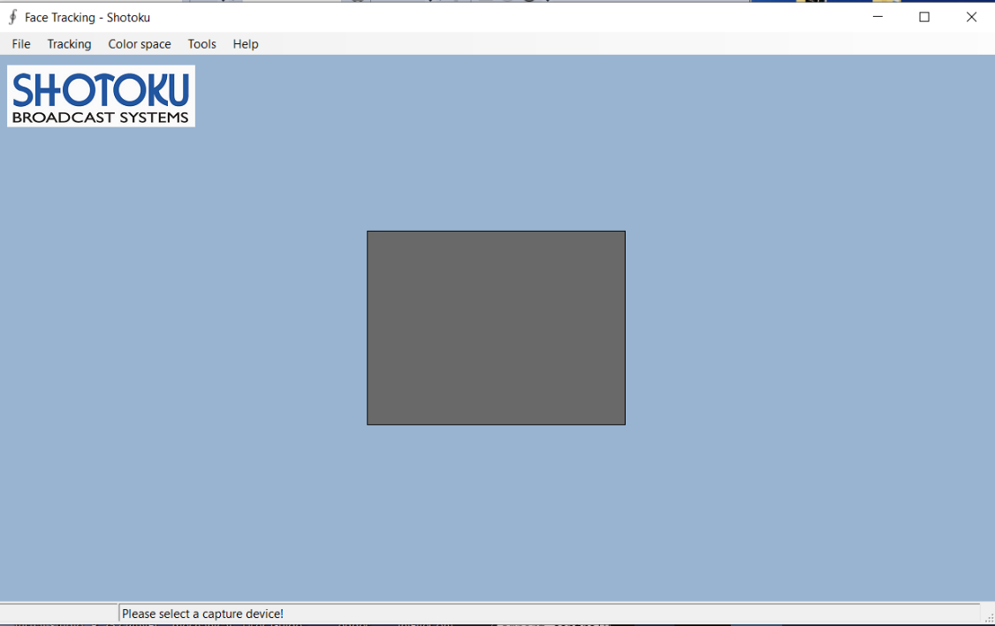

**Step 3**: Click **File** and **Open local video capture device**.

Select the **Blackmagic WDM Capture**.

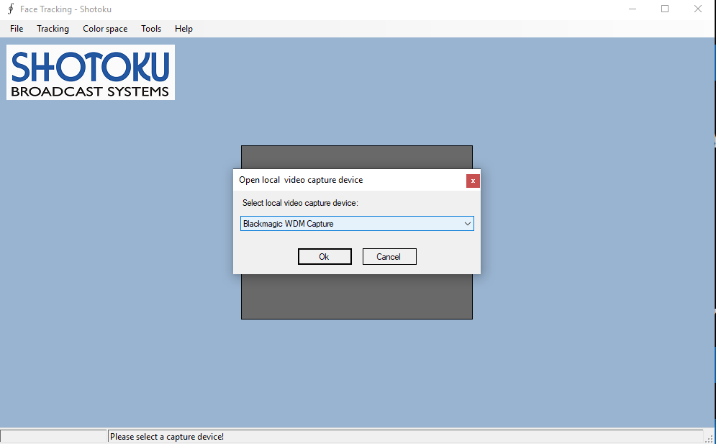

**Step 4**: Click **Tools**

Select **Display Mode** : Auto

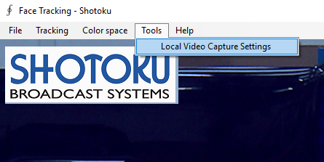

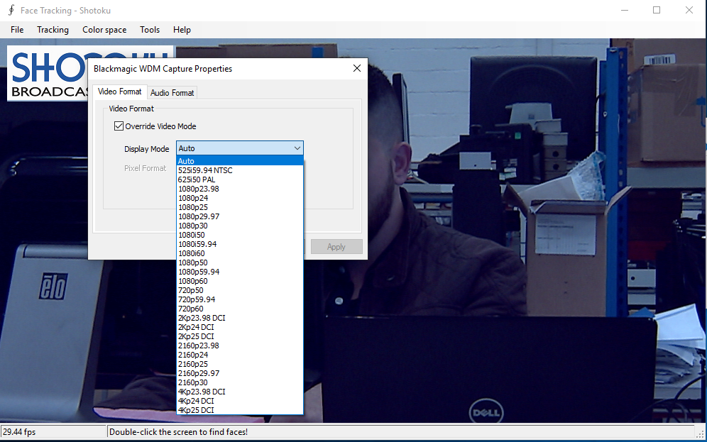

**Step 5: Click :** Tracking/Define Object

Draw a small rectangle in the center of the face

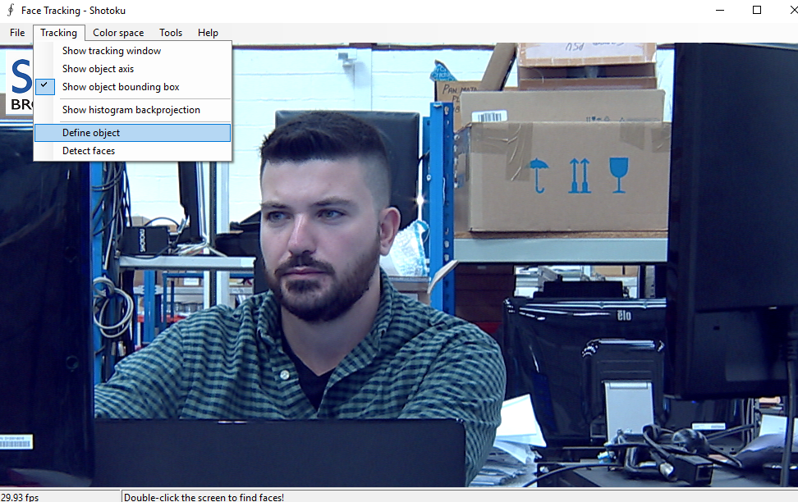

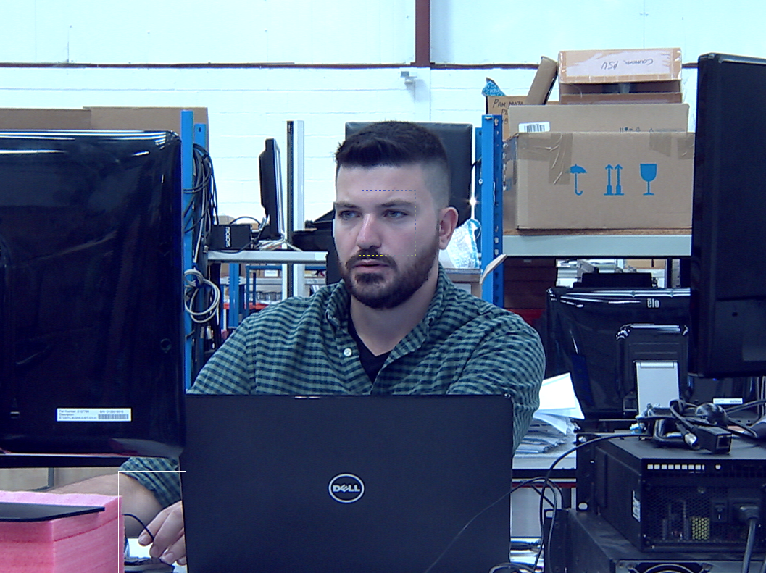



**Step 6 :** The pan and tilt speeds are set to zero as default. When the tracking is ready and fully working, we set them to 10 degrees/sec.

ec

**Step 7:** We adjust the x1,x2,y1,y2 sliders so the face will be kept in the center of the screen.



Windows tracking application : V.10

Processing Java Calibration application : V.6

For the above versions require :

* T computer ip **:192.1.0.14** , port :**13579**
* Tcontroller.ini : **StarAutomationPort=13579,StarAutomationAlwaysOn=1,AutomationIPAdress1=192.1.0.14,RoboticsServer=1**
* Windows computer ip :**192.1.0.27**
* Cmc ip : **192.1.0.132**